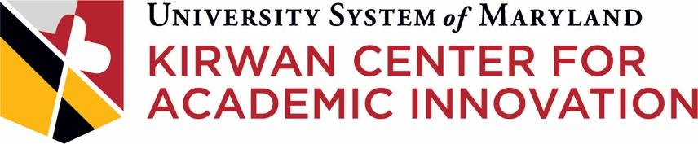

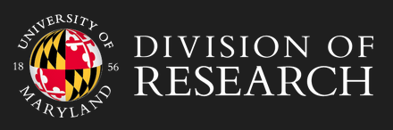

Creating a Systemwide IRB for the Scholarship of Teaching and Learning (SoTL)
A joint project of the USM Kirwan Center for Academic Innovation and the University of Maryland, College Park (UMCP) Human Research Protection Program

INTRODUCTION
In Fall 2021, the Kirwan Center for Academic Innovation partnered with the Human Research Protection Program in the UMCP Division of Research to develop a Systemwide IRB protocol for USM faculty engaging in Scholarship of Teaching and Learning (SoTL) research projects that pose minimal risk to participants. The Kirwan Center oversees the standing SoTL IRB protocol that has been approved by UMCP’s Institutional Review Board.

We define SoTL as the systematic investigation of student learning, instruction, and/or teaching innovations and the dissemination of findings so as to contribute to a broader knowledge community. SoTL projects at their essence aim to improve student success by providing an evidence base to help inform course design and instructional decisions undertaken by faculty and programs.

With the protocol and appropriate institutional agreements in place, USM faculty can propose specific SoTL projects using a streamlined amendment form that will go to the UMCP IRB for expedited review. The process will allow faculty to complete a simple form and receive a timely turnaround on project proposals while freeing up precious time for local IRBs across the System. The process will also potentially streamline multi-site research projects within the System, as well.

PROJECT PHASES
The project’s development phase culminated in the creation of a USM SoTL IRB protocol, which was approved by UMCP’s IRB in July 2022.

Moving into the pilot phase starting in Fall 2022, a subset of USM institutions will complete reliance agreements that state that the institutions will rely on UMCP’s IRB to approve specific projects that fall within the parameters of the USM SoTL IRB protocol. UMCP will maintain a record of all signed agreements. Each institution will retain a copy of their signed reliance agreement.

Post-pilot, the remaining USM institutions will be invited to complete reliance agreements to join the project. If most or all USM institutions complete reliance agreements, the USM SoTL IRB protocol will potentially streamline the process by which faculty can engage in multi-site SoTL research projects across the System, as well.

The Kirwan Center will provide updates on the overall project, including the number and scope of research studies housed under the protocol, at least annually to provosts and system IRB points of contact. The Center will work closely with the USM Council for the Advancement of Teaching and Learning (CATL) to identify resources (e.g., templates, training modules) that can assist CATL members in supporting faculty embarking upon SoTL research, and the Center will also explore the creation of SoTL research fellowships and a Systemwide SoTL research symposium.

FOR MORE INFORMATION
For more information, contact Nancy O’Neill, Acting Director, USM Kirwan Center for Academic Innovation, at cai@usmd.edu.

