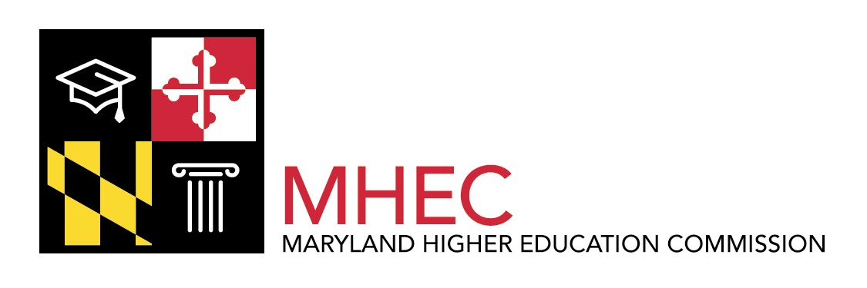 Contacts: Helen Szablya
410-260-4511
Anne Moultrie
301-445-2722

Statewide Survey Shows Strong Public Support
for Maryland’s Colleges, Universities
Voters Give Higher Education High Marks for Quality, but Have Concerns Over Affordability

Annapolis, MD (November 20, 2006) -- Most Marylanders have a very favorable impression of the state’s colleges and universities, and believe that Maryland’s higher education institutions are better in quality today than they were 10 years ago, according to a survey of more than 1,100 registered voters across the state. But while respondents rated the state’s colleges and universities high for academic quality, many of the same voters voiced concerns about the affordability of higher education in Maryland.
These are among the key findings of a statewide survey conducted recently by a coalition of Maryland’s community colleges, four-year public universities, and independent colleges and universities.
Among other findings of the survey:
- When asked to rate what issues they believed should be the top priorities for Maryland’s leaders, respondents overwhelmingly cited education. Higher education, specifically, ranked fourth among a wide range of issues voters were asked to rate, in terms of importance, behind only K-12 education, crime and public safety, and health care.
- Respondents cite government funding as being of nearly equally importance for both primary/secondary education and higher education; 96 percent said it was “very important” or “somewhat important” in the case of K-12 education, compared to 92 percent for higher education.
- Voters see the three most important roles of Maryland’s higher education institutions as: teaching students how to think; preparing students for employment; and conducting research that benefits society.
- Students and their families are bearing a disproportionate responsibility for the cost of higher education, while the federal government should be doing more to keep it affordable, according to the survey respondents.

(more)

- Most voters consider government funding for education to be very important, from a public policy standpoint. Sixty-one percent of the voters specifically responded that government funding was “very important” in higher education and another 31 percent indicated it was “somewhat important.”

“This survey demonstrates clearly that most Marylanders feel very positively about the quality of higher education in our state, but it also shows that they are deeply concerned about issues of affordability,” said Dr. William E. Kirwan, Chancellor of the University System of Maryland. “It also indicates that the public is strongly supportive of government funding for higher education, particularly if it helps to ensure that the investments will help to keep higher education affordable and accessible.”
Maryland’s higher education community commissioned WB&A, a Baltimore-based market research firm, to conduct the statewide survey, which polled voters in all regions of the state. The survey was jointly commissioned by a coalition that includes the 13-institution University System of Maryland; St. Mary’s College; Morgan State University; Maryland Association of Community Colleges (MACC), which represents the state’s 16 community colleges; Maryland Independent College and University Association (MICUA), representing 18 independent colleges and universities; and the Maryland Higher Education Commission.
The organizations are working together in a coordinated effort to strengthen public awareness of the role of higher education in Maryland, through an initiative called “Solutions for Maryland’s Future.” The effort is being led by a steering committee comprised of state higher education leaders, including USM Chancellor Kirwan; H. Clay Whitlow, executive director of MACC; Tina Bjarekull, president of MICUA; Jane Margaret O’Brien, president of St. Mary’s College of Maryland; Earl S. Richardson, president of Morgan State University; and Calvin W. Burnett, Maryland’s Secretary of Higher Education.
Another key initiative of the Solutions for Maryland’s Future effort was a statewide “listening tour” that was conducted this fall by higher education leaders, who met with regional business leaders at eight different events held at higher education institutions around the state. The events were co-hosted by the higher education leaders, along with the Maryland Department of Labor, Licensing and Regulation, and the Governor’s Workforce Investment Board.
More information on the Maryland survey can be found at http://www.mhec.state.md.us/higherEd/SolMDFuture.asp.
“Solutions for Maryland’s Future” represents a statewide response to the national Solutions for Our Future campaign. More information on that effort can be found at www.solutionsforourfuture.org.
# # #

