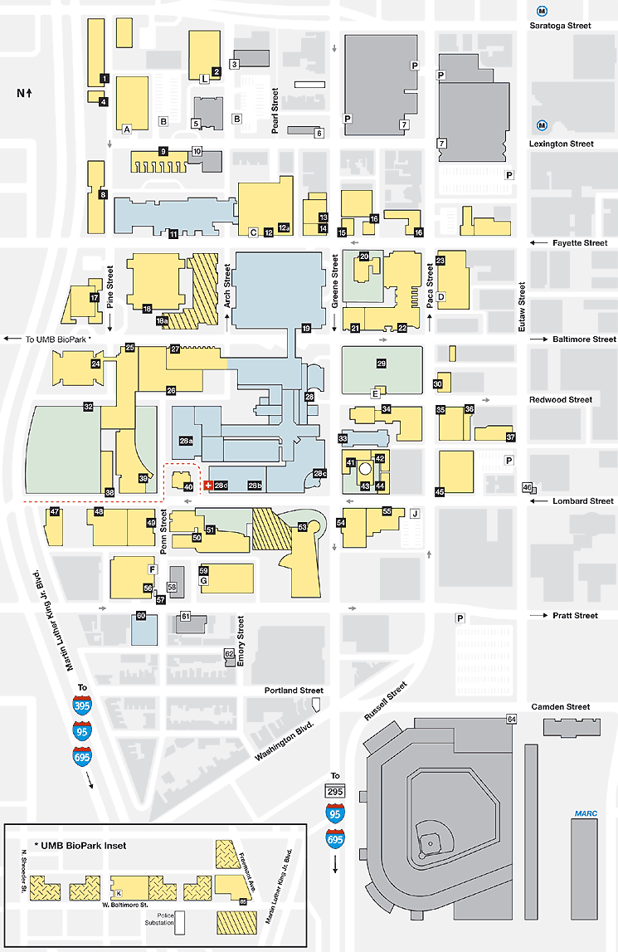
University of Maryland, Baltimore

Health Sciences and Human Services Library

601 W. Lombard Street

