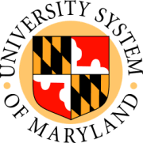

USM Board of Regents

Meeting of the Committee on Finance
Public Session
UMBC

11:15 a.m. November 20, 2008

- Opening Fall 2008 Enrollment and FY 2009 Estimated FTE Report (presentation and information)
- University of Maryland Biotechnology Institute: 2007 – 2017 Facilities Master Plan Update (action)
- Proposed FY 2009 Contract between the University of Maryland, Baltimore and the University of Maryland Medical System Corporation (action)
- University of Maryland, Baltimore: Renewal of System-wide Scientific Supplies Contract (action)
- Plan Document – USM 403(b) Supplemental Retirement Plan (action)
- Plan Document – USM 457(f) Contingent Deferred Compensation Plan (action)

