Creating a sustainable professional network

of K-16 science faculty

David May and Nancy Shapiro
University System of Maryland

Basmat Parsad and Joy Frechtling
Westat

2008 NSF MSP Learning Network Conference

1. Context of the work to be presented:

The Vertically Integrated Partnerships K-16 project (“VIP K-16”) is an NSF-funded Math and Science Partnerships grant. The project involves the partnership of one large school district, one community college, and several universities. VIP K-16 aims to improve science instruction in Maryland high schools and universities by providing science teachers and faculty with many opportunities to network, share experiences, and learn from each other about inquiry instruction and course reform.

The assumptions behind this plan are similar to those of NSF’s MSP program as a whole: that partnership among K-12 and IHE institutions will enhance teaching and therefore learning by students at both kinds of school. Existing research on professional learning communities, particularly of teachers, suggests that these benefits to teaching may come not only from partnerships of institutions, but also from collaborations among the teachers themselves. Therefore, one of the primary goals of VIP K-16 is to strengthen and grow interactions among higher education and K-12 institutions at multiple levels, including the teacher level.

Many components of the project were therefore designed to involve K-12 teachers, higher-education faculty and students, and/or project leaders in collaborations and learning communities. These collaborations focus on further redesigning and implementing curriculum at both levels or on designing professional development and other grant activities. Among them are:
- Science research experiences for teachers, with ongoing support for bringing real scientific inquiry to the classroom in collaboration with their peers;
- Undergraduates in the classroom: High-school classroom internships for undergraduate science majors, who are partnered with science teachers;
- Teaching assistant training programs in science departments;
- Faculty learning communities in which faculty team up (often with teachers) to redesign instruction or plan further professional development.
- Master Science Teachers, a team of dedicated professionals who spend extra time planning and leading all aspects of grant activities for K-12 teachers.

2. Claim(s) or hypothesis(es) examined in the work:

In working on the project, its directors sensed that meaningful connections were being made among participants and a network was being formed that did not exist before the project’s inception. It was suspected that this network is extensive, and that those participating felt they were benefiting from the collaborative relationships they’d made. It was also unclear whether a few key project leaders were holding the network together, or if the connections being made would disappear should these leaders leave their leadership roles for some reason (such as the end of the grant). This study seeks to examine these claims, leaving aside for the moment the possible effects of this network on actual teaching practice or student learning.

The specific questions for study are:
- What is the overall level of collaboration among VIP K-16 participants? How has it changed since the beginning of the grant?
- Who are the key connectors in VIP K-16 network? Is their presence in the network necessary for connecting the non-key members?
- Do participants perceive benefits to themselves and their students as a result of collaboration? Under what conditions do they feel these partnerships are sustainable?

3. Study design, data collection and analysis:

To answer these questions, social network analysis was used to study the growth and character of this network. First, four areas of program activity were identified around which professional collaborations have occurred:
- Sharing or developing new teaching strategies or materials that emphasize inquiry-based teaching and learning;
- Mentoring relationships, either to mentor or be mentored, in inquiry-based teaching and learning;
- Delivering activities that expose graduate or undergraduate students to science teaching as a career option; and
- Planning, coordinating, or managing VIP K-16 grant activities.

In each of these areas, the aim was to examine both the overall levels of collaboration made possible by grant activities, and the position of leadership within the networks.

To answer the study questions on the overall level of collaboration (i.e., the size of the network) and the role of key connectors, surveys of program participants were used; they were given in Spring 2006 (the large number of participants made individual or group interviews unfeasible). Each selected participant was given a list of all other participants and asked to indicate with whom they were working collaboratively in each of the four program areas listed above, both before the VIP grant commenced and when the survey was administered. The survey item for the first program area, for example, was written as follows:
Which of the VIP participants did you work with in sharing or developing new teaching strategies or materials that emphasize inquiry-based teaching and learning? Consider substantive or ongoing collaboration, including collaborative activities during workshops or formal professional development. Place an X in the first column if you worked with the person before the VIP program and an X in the second column if you worked with the person during the program.

The 134 names listed on the survey were those of all participants in any of the VIP program areas in which meaningful collaborations or relationships were possible, as determined by project directors. Contact information was not available for 10 of these 134 participants, and 25 did not respond to the survey request, leaving 99 respondents. Although the absence of these 35 non-respondents might mean the network is larger than was measured, it could not be smaller.

The survey data were used to describe (both numerically and graphically) the networks that existed for each of the program areas both before the VIP grant began and in Spring 2006. The social networking software Ucinet was used to analyze the data and produce before-and-after networking diagrams and egonets for each program area.

This survey methodology is limited in what it could tell about the nature of the collaborations that existed and the perceptions of the participants about their involvement (the third study question). Therefore, a second stage of the study was designed, consisting of single interviews with 14 selected participants representing a range of roles in the project and places in the network. The purpose of the interviews was to examine the types of collaborations that existed for certain types of participants and identify their perceptions of the sustainability and value of those professional relationships.

A third stage is planned that will entail a repeat of the survey, to see how the network has changed as the project matured and as some participants left and new ones joined.

4. Results or knowledge claim:

All program areas showed large increases both in the numbers of collaborations among participants, and in the numbers of “vertical” partnerships – those that were between a K-12 teacher and an IHE science faculty member. The numbers of collaborations within each area before and since the VIP project are shown in Table 1.

Table 1. Increases in the numbers of collaborative relationships among VIP participants and in “vertical” collaborations between K-12 and IHE faculty, in four program areas.
Area of collaboration | Number of collaborations |  | Change | Number of “vertical” collaborations |  | Change
Area of collaboration | Before VIP  (2002) | Spring 2006 | Change | Before VIP  (2002) | Spring 2006 | Change
Inquiry instruction | 194 | 711 | 4x | 19 | 181 | 10x
Mentoring relationships | 25 | 175 | 7x | 7 | 69 | 10x
Undergraduate teaching interest | 42 | 154 | 4x | 5 | 49 | 10x
Planning VIP activities | 85 | 623 | 7x | 26 | 195 | 8x

The graphical networking diagrams display very dramatic changes in all program areas. As an example, the diagrams for program area 1 (sharing inquiry teaching strategies) are shown in Figure 1 (the overall network) and Figure 2 (“vertical” collaborations).

Fig. 1. Networks on sharing new inquiry science teaching strategies or materials: before and since VIP.
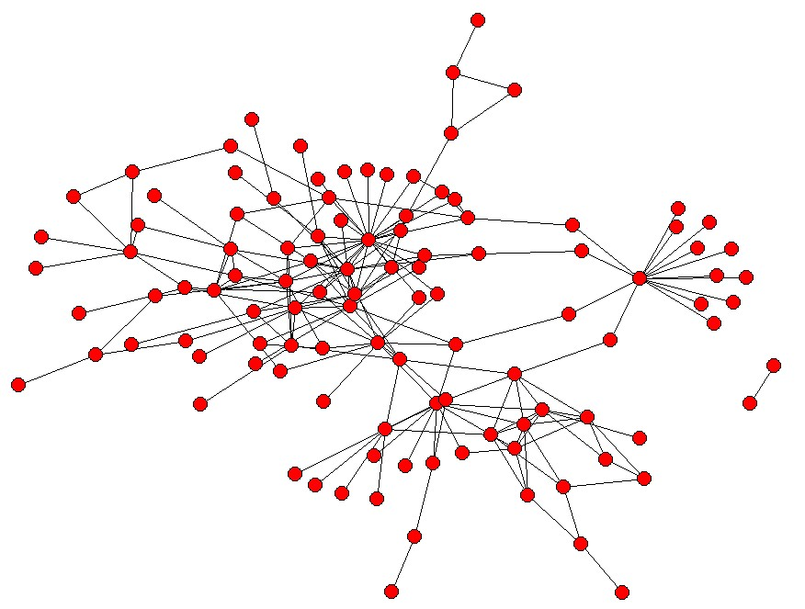 | 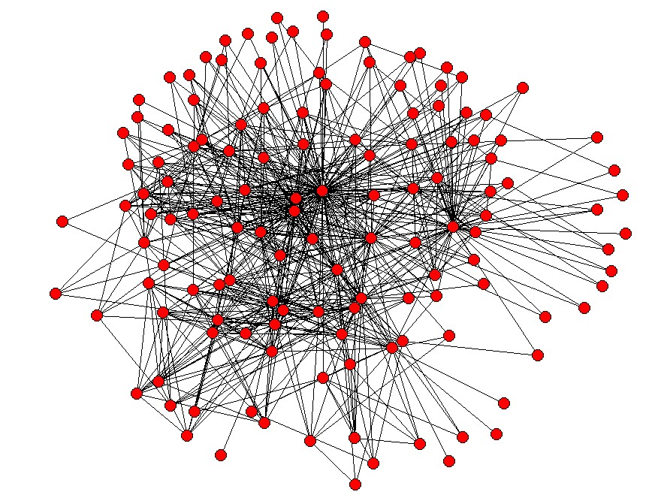
Before VIP (2002) | Spring 2006
N=134 (Network participants= 110; Isolates = 24)  Number of possible ties = 8,911  Number of ties in network = 194  Percent of possible ties in network = 2.2% | N = 134 (Network participants= 134; Isolates = 0)  Number of possible ties = 8,911  Number of ties in network = 711  Percent of possible ties in network = 8.0%  Number of new ties = 517
NOTE: Detail may not sum to totals because of rounding.
SOURCE: Survey on Collaborative Ties Within the Vertically Integrated Partnership (VIP) Program, 2006.

Fig. 2. “Vertical” networks on sharing new inquiry science teaching strategies or materials: before and since VIP.
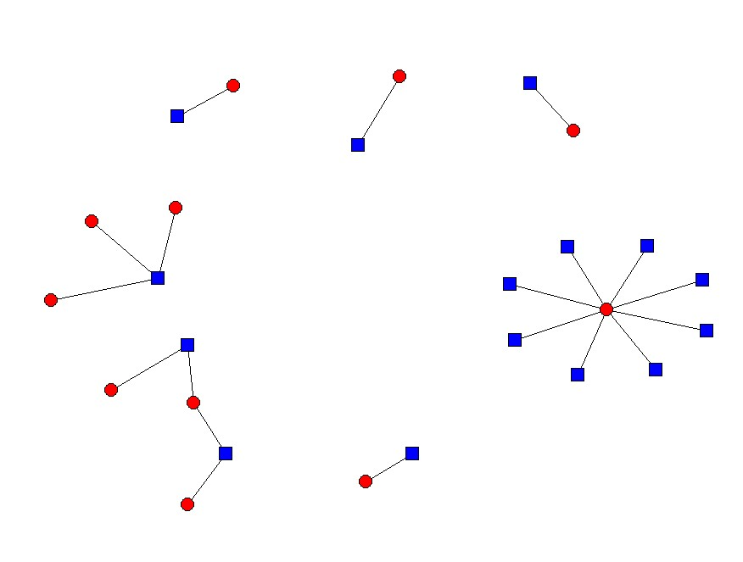 | 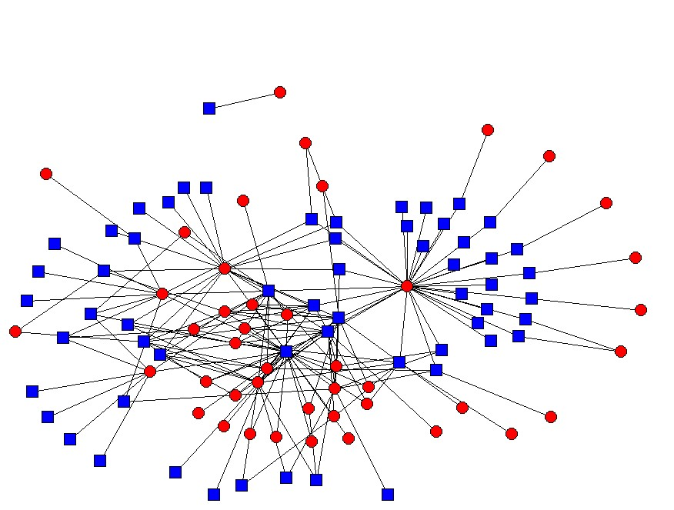
Before VIP (2002) | Spring 2006
N=134 (57 IHEs and 77 MCPS)  Network participants = 26; Isolates = 108  Number of possible ties across groups = (57x77) = 4,389  Number of ties across groups = 19  Percent of possible ties across groups = 0.4% | N=134. (57 IHEs and 77 MCPS)  Network participants = 101; Isolates = 33  Number of possible ties across groups = (57x77) = 4,389  Number of ties across groups = 181  Percent of possible ties across groups = 4.1%  Number of new ties = 162
Key:  = IHE faculty  = K-12 faculty
NOTE: Detail may not sum to totals because of rounding. The networks focus only on ties between IHE and K-12 participants and they do not include ties within each of the two groups.
SOURCE: Survey on Collaborative Ties Within the Vertically Integrated Partnership (VIP) Program, 2006.

In addition, the data show that a few key personnel are central to the networks and have connections with relatively many other participants. However, removing these people from the analysis in most cases does not disrupt the high density of the networks. In other words, while these key people are connected to a large number of others, the others are still connected to each other directly and not just through key leaders.

Again, these results indicate a large increase in the number of collaborations but not their intensity, something upon which the interview responses touched. The comments of those participants who were interviewed revealed the following themes:
- Minimal connections meant either minimal involvement, or intense collaboration with a few partners;
- Teachers and faculty liked the benefits to their teaching and curriculum, as well as the more collaborative work atmosphere engendered by the new connections.
- Challenges to continued partnership included time and geographical constraints; administrative resistance; and human fatigue.
- Sustainability of professional collaborations requires formal structures, which in turn require dedicated funding.

5. Conclusions and implications:

The surveys and interviews show the extent to which new (and sustainable) professional networks emerged from interactions among VIP participants within and across institutional and group boundaries. Through different kinds of activities, a substantial network has developed, comprised of new professional relationships among teachers and faculty.

The value of such relationships is suggested by what the interviewees report: improved instruction and mutual support at the local (teacher) level. The value of a network of such relationships is that it represents fertile ground for future reform efforts on larger scales. It is hoped that this study of the VIP K-16 network will help leaders of other partnership projects to create, nurture, and evaluate professional networks in their own situations.

