|  |  |  |
| --- | --- | --- |
|  | **Bowie State University** |  |
| X | Trish E. Johnson | Primary |
|  | Trenita Johnson | Primary |
|  |  | Alternate |
|  |  | Alternate |
|  | **Coppin State University** |  |
| X | Steve Delice | Primary |
|  | Sherrye Larkins | Primary |
| X | Tim Casey | Alternate |
|  | Yvonne V. Cook | Alternate |
|  | **Frostburg State University** |  |
|  | Jay Hegeman | Primary |
| X | Jesse Ketterman | Primary |
| X | Rubin Stevenson | Alternate |
|  | Stacy Wassell | Alternate |
|  | **Salisbury University** |  |
|  | Lisa Gray(Vice Chair) | Primary |
| X | Paul Gasior | Primary |
|  | Teri Herberger | Alternate |
| X | Kim Meyer | Alternate |
|  | **Towson University** |  |
| X | Mary Hickey | Primary |
| X | Jayne French | Primary |
|  | Deniz Erman | Primary |
|  |  | Alternate |
|  |  | Alternate |
|  |  | Alternate |
|  | **University of Baltimore** |  |
| X | Eric Jones | Primary |
|  | Michelle Junot | Primary |
|  | Keiver Jordan | Alternate |
|  |  | Alternate |
|  | **University System of MD Office** |  |
| X | Chevonie Oyegoke | **Chancellor’s Liaison to CUSS** |
| X | John Wolfe, Jr. | **Primary** |

|  |  |  |
| --- | --- | --- |
|  | **University of Maryland, Baltimore** |  |
|  | Amanda Azuma (Co-Secretary) | Primary |
|  | Roy Ross | Primary |
|  | Kevin Watson | Primary |
|  | Bill Crockett (Past Chair) | Alternate |
| X | Angela Hall | Alternate |
|  | Carl Jackson | Alternate |
|  | **Univ. of Maryland Baltimore County** |  |
| X | Laila Shishineh | Primary |
| X | Sheryl Gibbs | Primary |
| X | Kevin Joseph (Co-Secretary) | Primary |
|  | Tom Penniston | Alternate |
| X | Arthur Bezwada | Alternate |
|  |  | Alternate |
|  | **UM Center for Environmental Science** |  |
|  | Barbara Higgins | Primary |
| X | Curtis F. Henry | Primary |
|  | **University of MD, College Park** |  |
| X | Dana Wimbish (Chair) | Primary |
| X | Dylan Baker | Primary |
| X | Sister Maureen Schrimpe | Primary |
| X | Willie Brown | Ex-Officio Chr. |
| X | Debbie Grover | Alternate |
| X | Sarah Goff-Tlemsani | Alternate |
|  | David Klossner | Alternate |
|  | **University of Maryland Eastern Shore** |  |
|  | Chenita Reddick (Member At Large) | Primary |
|  |  | Primary |
|  |  | Alternate |
|  |  | Alternate |
|  | **University of MD University College** |  |
|  | Deanna Mayer | Primary |
| X | Debby Mathis (Member At Large) | Primary |
|  | Candace Johnson | Primary |
|  | Cynthia Steele | Alternate |
|  | Jade Walker | Alternate |
|  | Alyssa Petroff | Alternate |
|  |  |  |

Council of University System Staff

Council Meeting Minutes - Draft

November 9, 2015 – University of Maryland College Park

**X = In Attendance P = Attending by Phone**

#### AGENDA

**November 9, 2015**

**University of Maryland College Park**

**Benjamin Banneker Room 2212  
1:00 p.m.**

**Call to Order**

1. **Consent Agenda**
   * <http://bit.ly/1kOSTIt>
2. **Approval of Minutes from October Meeting**
3. **Chair’s Report**
4. **Chancellor’s Liaison’s Report – Chevonie Oyegoke**
5. **Committee Meetings**
6. **Committee Updates**
   * **Benefits and Compensation**
   * **Board of Regents Awards**
   * **Communications and Marketing**
   * **Legislative and Policy**
   * **Executive Committee**
7. **Old Business**
   * **Items moved off of Consent Agenda**
8. **New Business**
   * **Technical review of Constitution and Bylaws for CUSS**

**Conference Call Information**

**Dial-in Number: 1-301-405-2900**

**Participant Access Code: 248782**

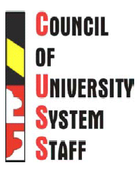

***Bowie State University****14000 Jericho Park Road  
Bowie, MD 20715*

***Coppin State University****2500 W. North Avenue  
Baltimore, MD 21216*

***Frostburg State University****101 Braddock Road  
Frostburg, MD 21532*

***Salisbury University****1101 Camden Avenue  
Salisbury, MD 21801*

***Towson University****8000 York Road  
Towson, MD 21252*

***University of Baltimore*** *1420 N. Charles Street  
Baltimore, MD 21201*

***University of Maryland, Baltimore****620 W. Lexington Street  
Baltimore, MD 21202*

***University of Maryland  
Baltimore County****1000 Hilltop Circle  
Baltimore, MD 21250*

***University of Maryland Center for Environmental Science****P.O. Box 775  
Cambridge, MD 21613*

***University of Maryland,   
College Park*** *College Park, MD 20742*

***University of Maryland   
Eastern Shore****Princess Anne, MD 21853*

***University of Maryland   
University College*** *3501 University Blvd. East  
Adelphi, MD 20783*

***University System of Maryland Office*** *3300 Metzerott Road  
Adelphi, MD 20783-1690*

**Agenda for CUSF/CUSS/USMSC Joint Meeting at UMCP**

Stamp Student Union Colony Ballroom

Room 2203

Monday November 9, 2015

9:00 Continental Breakfast and Informal Discussions

10:00 Introductions and Welcome from President Loh

10:20 Strategy for Legislative Session

Director of Legislative Affairs – Andy Clark

10:50 Introduction of Joint Motion 1512

CUSF Chair Virletta Bryant

Motion 1512: In the spirit of shared governance CUSF, CUSS and USMSC recommends

revising USM’s Presidential Search Policy to delineate a configuration of standing

positions on institutional presidential search committees, with one standing position

each reserved for the elected leadership of faculty, staff and students or his/her

designee. In the case of a University Senate or Assembly the governing body will send

recommendations to the Chancellor for each standing position.

11:00 Remarks from the Chancellor

Chancellor Robert Caret

11:30 Effectiveness and Efficiency 2.0

USM Center for Academic Innovation- MJ Bishop

11:50 Break-out Sessions

12:30 Lunch

1:00 CUSF/CUSS/USMSC Separate Meetings

2:30 Adjournment

All Times Approximate

+/- Grading System

With what started as a Student Council Executive Board initiative, the examination of each

University System of Maryland institution’s grading system or scale has become a hot topic

among student leaders, professors, and staff members, particularly within registrar’s offices.

The conversation around USM uniformity with regards to the +/- Grading System will require

multiple perspectives and approaches in order for a substantive resolution to be reached.

Spousal Benefits

During this discussion breakout session, conversations and examinations of USM institutional

spousal benefits will be discussed. While this topic primary focuses on faculty and staff

members, students who are married and are employees of the system are encouraged to join in

on the conversation.

Mental Health and Resilience

Mental health awareness has been a major topic of advocacy and discussion for each of the

respective councils. When our students, faculty, and staff are mentally healthy, they become

more proactive and productive on their campuses. During this breakout session, members of

each Advisory Councils will join together to discuss best practices and initiatives to undertake to

better eradicate the concerns around mental health and to boost levels of resilience for

students, faculty, and staff members.

Cultural Competency

As student, faculty and staff populations at USM institutions become increasingly diverse, there

is a need to develop cultural competencies, (i.e. the skills and awareness related to issues such

as culture, language, race and ethnicity). During this breakout session, members will discuss

training, current practices and best practices for collaboration, learning and working together

effectively in cross-cultural situations.

Effectiveness and Efficiency 2.0

This session will continue the discussion initiated by MJ Bishop. E&E 2.0 continues the USM

initiative to garner savings and lower costs while increasing the quality of education through

innovation, entrepreneurship and accountability. Collaboration through system-wide and

institutional operations will be discussed.

**Joint CUSS/CUSF/USMCS meeting**

**Call to Order**

1. **Welcome by Dr. Loh**
   * Expressed importance of shared governance and the importance of having all three groups (faculty, staff and students)
2. **Introduction of Senate members**
3. **Remarks from Chancellor Caret**
   * Discussed various issues including:
     1. Importance of communication and getting people involved
     2. CUSF survey – only 3 institutions had real issues
     3. Importance of economic development and education in Baltimore
     4. Importance of state funding
     5. Faculty compensation
4. **Discussion of Motion 1512**
   * Purpose of motion was to make sure shared governance was officially part of president searches
   * Questions and concerns about language
   * Group worked to rework the language
   * Vote was taken on new language – outcome unknown
5. **Strategy for Legislative Session**
   * Remarks from Director of Legislative Affairs – Andy Clark
   * Governor, and many legislators, are entering 2nd year
   * Budget somewhere between -2% to 2%
   * Working with the Governor on various issues
     1. Economic development
     2. Research and public service
     3. Commercialization of transfer technology
     4. Structural deficit issue – Medicaid and pension costs
   * Question was asked if we should work to get legislators to visit institutions
     1. Each campus has a legislative/government affairs/relations person – should reach out through them
   * Faculty unionization bill may come up
   * Continuing questions about college costs – are we spending our money wisely
6. **Effectiveness and Efficiency 2.0**
   * Remarks from Dr. Joann Boughman
   * 1.0 saved over $600 million
   * Asking for cross-campus initiatives
   * Opt-in approach
   * Procurement processes – MEEC is an example
   * Library consortia
   * 2.0 focused on student success initiatives
   * SB 740 and pathway improvement
   * PAR student success matrix
   * Looking at programmatic programs and outcomes – such as First Year initiatives
   * Looking at student costs outside of tuition
   * MD open source textbook initiative
   * Focus on student retention as part of student debt
7. **Break-out Sessions and reports**
   * +/- Grading System
   * Spousal Benefits
   * Mental Health and Resilience
   * Cultural Competency
   * Effectiveness and Efficiency 2.0

**CUSS Meeting**

Abbreviated meeting due to the length of the joint meeting

**Call to Order**

1. **Consent Agenda**
   * <http://bit.ly/1kOSTIt>
2. **Approval of Minutes from October Meeting**
   * Approved by consent
3. **Chair’s Report**
   * Kim Myers – new Salisbury representative
   * Rosario F. Van Daalen, former Chancellor’s Liaison to CUSS, in attendance
   * November 15th deadline for next CUSS newsletter
   * Next month will start technical review of CUSS by-laws
4. **Chancellor’s Liaison’s Report – Chevonie Oyegoke**
   * Reminder of open enrollment ending November 16th
5. **Committee Meetings**
   * No committee meetings or updates

Next meeting Tuesday, December 8, 2015 at USM Office

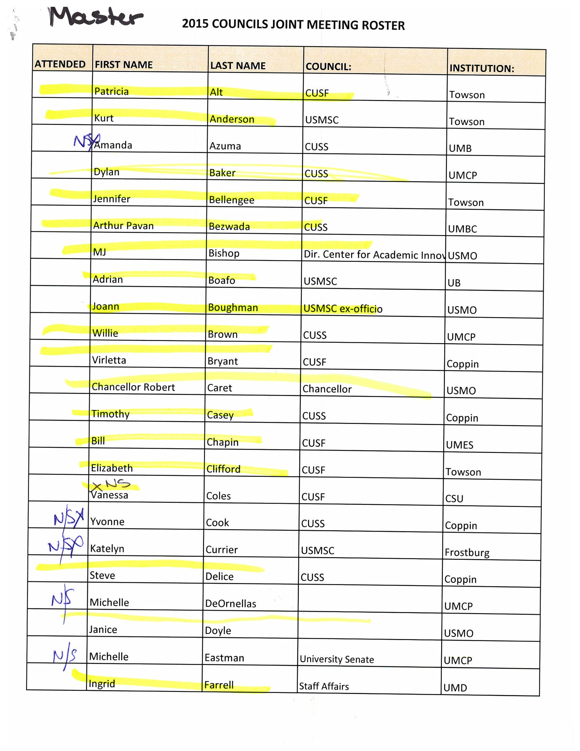







**Macintosh HD:Users:kjoseph:Documents:CUSS:MOTION 1512.Background.pdf**

**Macintosh HD:Users:kjoseph:Documents:CUSS:MOTION 1512. A Resolution Recommending a Change to the University System of Maryland.pdf**