Council of University System Staff

AGENDA
Tuesday, October 23, 2018
Frostburg State University

- Call to Order
  - On the phone: Sherry, Nicole, Amy, Mike, Candace, Adrienne
- Welcome and Introductions by President Ron Nowaczyk
  - President of FSU since 2016
  - Focus on importance of shared governance, in the system, and at FSU during his tenure
  - Just finished strategic planning process at FSU with a ton of campus engagement – one strategic goal/action item is to start to develop faculty/staff professional development plans and have that be part of their annual evaluation (won’t happen overnight but will work towards this as a goal) – with the hopes that this will help with continuity and succession planning
  - Questions:
- Will the EdD program be moving online? Exploring the potential right now, most likely will move to hybrid not just entirely online
- What is the student population at FSU? Fairly diverse population, lots of first generation students, highest number of RN graduates, although campus growing increasingly diverse some challenges around issues of inclusion, somewhat isolated given geographic location so need to focus on opportunities/activities for students, trying to bring in senior leadership from diverse backgrounds
- Plan for implementation of professional development plan? Will be tracked electronically and tied to performance evaluations (trackstar system currently being used?), articulate their goals, capture that in their evaluations annually, includes training for supervisors as well
- Consent Agenda & Materials October Agenda & Meeting Materials
- Approval of Minutes from September, 2018
  - Minutes Approved
- Chair’s Report
  - CUSS was invited to participate in a Title IX Workshop and then asked not to participate due to issues around attorney/client privilege – so we will be kept in the loop about what is covered and if there are meetings we can attend
  - Also asked to participate in a Free Speech Committee (will select someone from the Executive Committee)
  - Will discuss changes to retiree Rx plans under “old business”
  - Mark attended the Board of Regents meeting on behalf of Lisa last week – Dr. Perman presented on health care profession outcomes in the state
  - Letters will be going to leadership at each campus about our service to CUSS
- Chancellor’s Liaison’s Report
  - 2% COLA effective January 1, and confirmed that 0.5% COLA effective April 1 plus a $500 bonus for all employees
  - Currently open enrollment – not everyone has received their packets: employees will receive a new ID (“W” number) which will replace your social security number
- Committee Meeting
  - Break into committee meetings
- LUNCH (Tentative Working Lunch)
- Committee Reports
  - Benefits and Compensation
    - Third shift employee impact when there are campus delays/closures
  - Board of Regents Awards
    - Process has changed from last year
    - Committee will do the grading on their own (others can volunteer if interested)
    - Making sure each campus has a rep on the committee to be fair
  - Communications and Marketing
    - Quarterly newsletter plans: staff senate best practices (from the survey or from chairs of senates at each campus), alternating each issue to highlight different committee work within CUSS
    - Have most updates from PoC but will reach out to those who still need to submit
    - CUSS info sheet should be sent out soon for everyone
  - Legislative and Policy
    - Initial planning for Annapolis day – still trying to meet with Andy Clark and Patrick Hogan (hopefully soon)
    - Reaching out to government affairs people on respective campuses to make sure we are addressing the issues of concern
    - Possibly drafting a letter on behalf of CUSS about our position towards the retiree Rx issue – want to understand the real impact first – if interested in helping to draft the letter, reach out to Nicole
    - Also looking at different policies across campuses around administrative leave and closure in general in terms of how people are notified and when to come back – definition of essential employee on each campus (like Benefits & Compensation question)
  - Executive Committee
    - Joint meeting: Friday, 11/16 at UMCP – RSVP coming tomorrow but must RSVP by 11/2 if attending (for catering) – will only have about 30 minutes together as CUSS due to BOR panel and Academic Integrity panel
    - Working to invite Chancellor as well as Chairman Brady to one of our spring meetings
- Old Business
  - Prescription Plan Changes for Retirees
    - We need to figure out what our stance/approach is/will/should be
    - Mostly unanimous response in figuring out an actionable next step
    - Make sure we have reps from every campus on the legislative and policy committee
    - Legislative committee will be investigating the issue further, including the court decision, and reach out to campus government relations departments
  - Best Practices Survey (Mark)
    - More info coming soon
  - Ad-hoc bylaws committee (Mark)
    - Committee completed a questionnaire to gather input and questions
    - Upcoming conference call based on results/responses from the questionnaire being scheduled for Nov.
    - Potentially exploring attendance, term limits, funding from institutions to support attendance, etc.
  - Question for November Joint meeting
    - Any additional questions to consider
    - Discussion around free community college and impact on four-year institutions and impact on infrastructure
    - If there are other questions we REALLY want to ask, don’t be afraid to ask the day of
- New Business
  - Towson: alum has a new show out on Netflix
  - Bowie: posted ombudsman position
  - USM: go to USM website and look for employment opportunities across all of USM (under “Human Resources” then “Employment Opportunities”)
- Institution Updates
- Adjourn

Conference Call Information
Dial-in Number: (712) 770-4010
Participant Access Code:879787#
Next Meeting Friday 15 November at University of Maryland, College Park

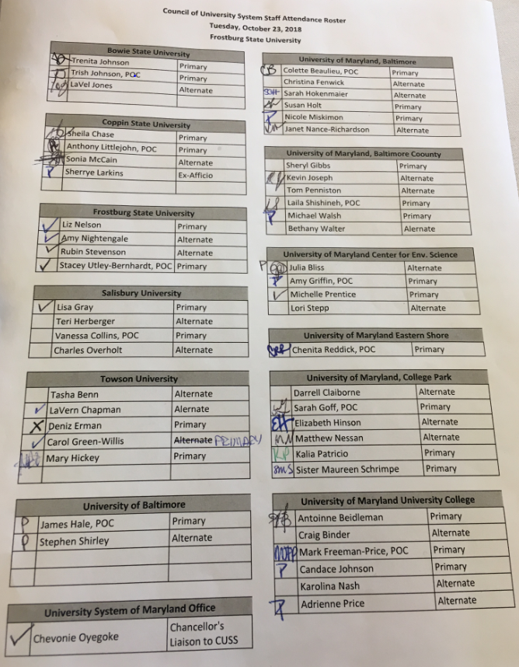
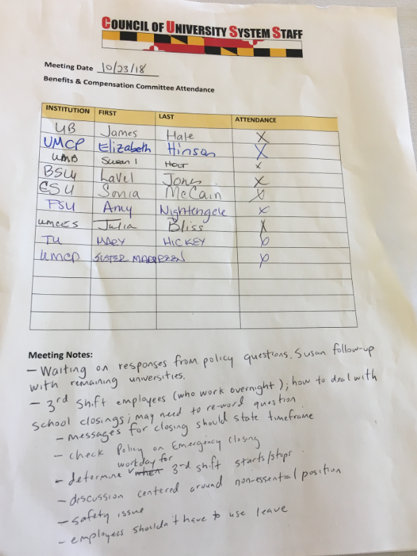
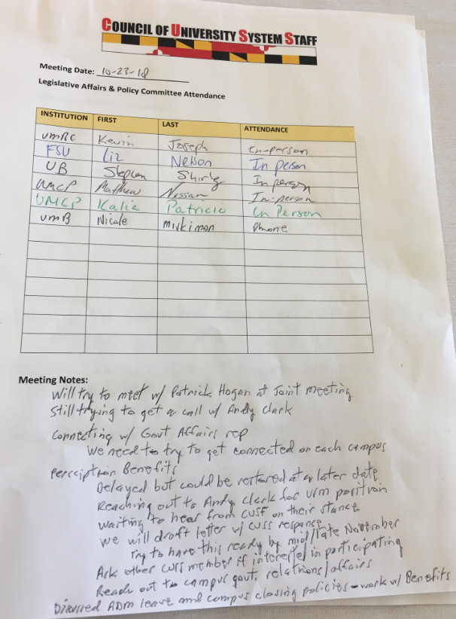
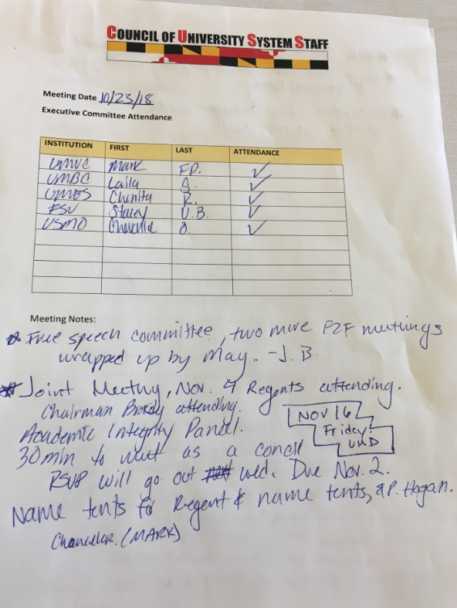
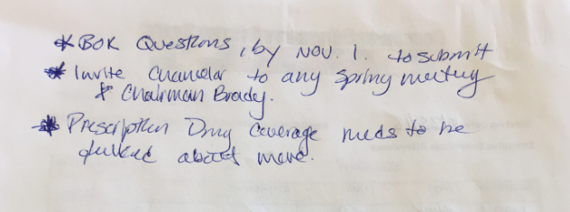
Executive Committee Continued…
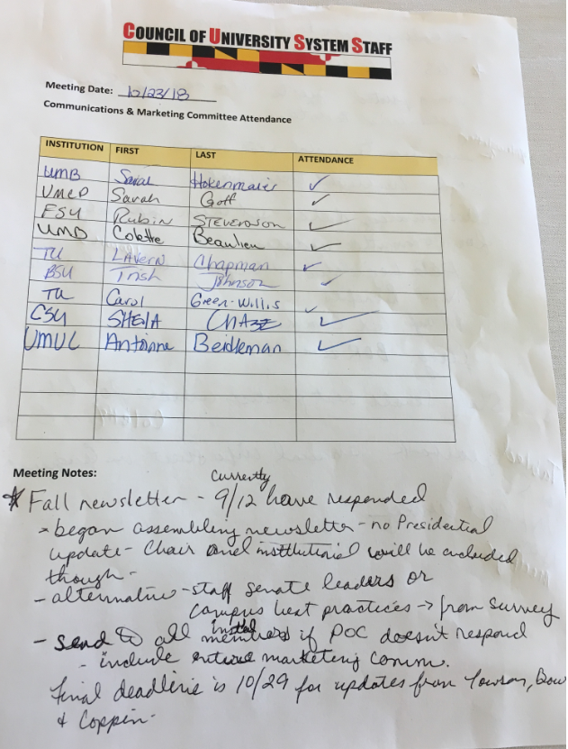
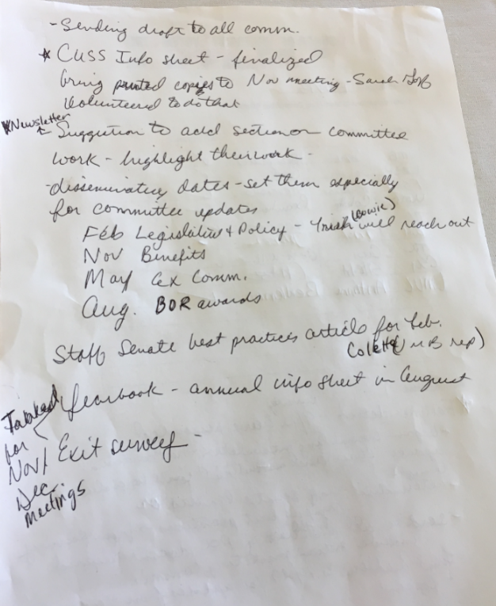
Communications Continued…

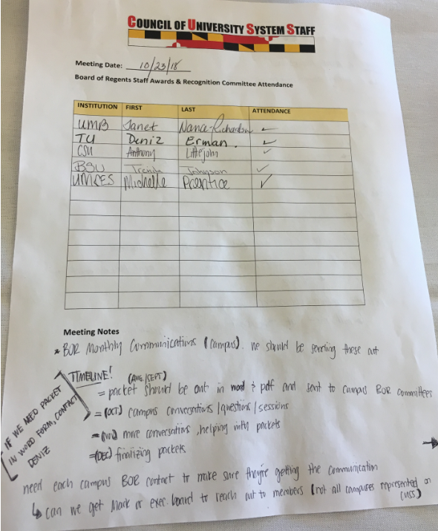
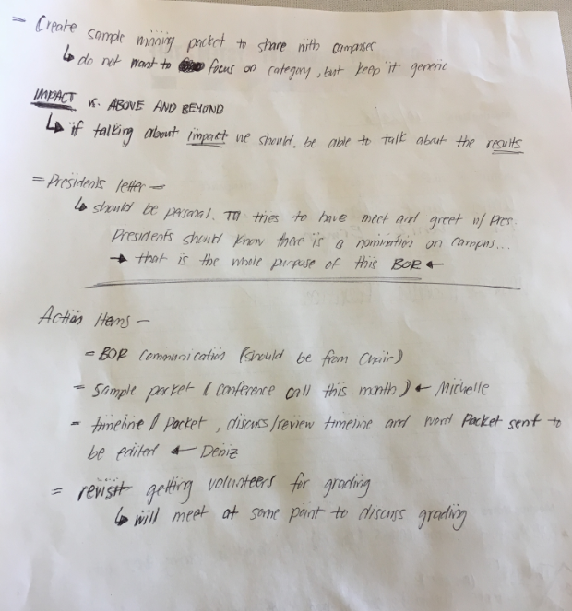
BoR Awards Continued…

